**How I will show what I have learned?**

I can describe the transatlantic slave trade triangle.

I can describe the Black Lives Matter movement.

I can identify some of the events that have sparked the Black Lives Matter protests.

I can describe ways in which different communities can be brought together.

I understand how I can have a positive effect on community cohesion.

**Year 6**

**History Topic: BHM – What is the ‘Black Lives Matter’ Movement?**

**Seamer and Irton CP School – Knowledge Organiser**

**What’s next?**

**KS3:** Know and understand the history of these islands as a coherent, chronological narrative, from the earliest times to the present day: how people’s lives have shaped this nation and how Britain has influenced and been influenced by the wider world

**Prior Knowledge**

Year 3 - Introduction to Black history

Year 4 - Significant influential people

Year 5 – The Empire Windrush

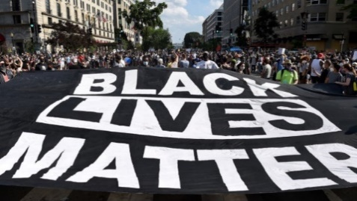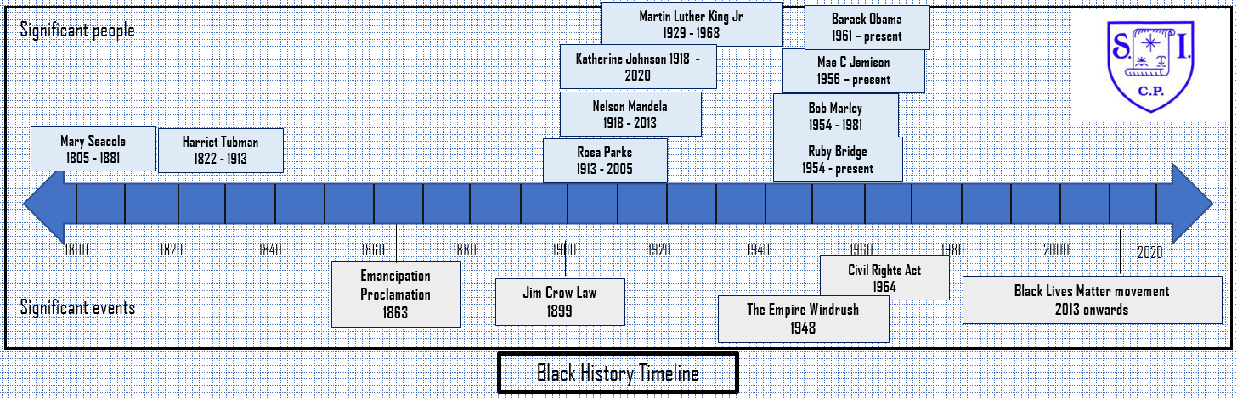

**Key vocabulary I need to know**

Racism

Anti-racism

Enslaved people

Police brutality

White privilege

Unconscious bias

Activist

Institutional/systematic racism

**Key Knowledge I need to understand**

* The transatlantic slave trade was the largest forced migration in history.
* Between 1500 and 1800, around 12-15 million people - some historians suggest the figure may have been higher - were taken by force from Africa to be used as enslaved labour in the Caribbean, North, Central and South America. Enslaved people were traded for guns, rum, cotton, tobacco
* As a result of the transatlantic slave trade, millions of people of African descent live across the world.

1807 - Slavery abolished.

1834 - Enslaved people in Britain are freed.

1966 – The first Notting Hill carnival.

2013 – Black Lives Matter organisation first created.

2020 – Protests take place around the world after the death of George Floyd.

George Floyd Jr. was an African-American man who was murdered by a police officer in Minneapolis, Minnesota, during an arrest made after a store clerk suspected Floyd may have used a counterfeit twenty-dollar bill.

Notting Hill Carnival is London’s biggest street party. The Carnival’s origins lie in race riots that saw the newly arrived immigrant population attacked by white nationalists.